**Assignment -3**

Cloud object storage and Watson assistant

|  |  |
| --- | --- |
| Assignment Date | 30 September 2022 |
| Team ID | PNT2022TMID36906 |
| Maximum Marks | 2 Marks |

**Question-1:**

Create a Bucket in IBM object storage

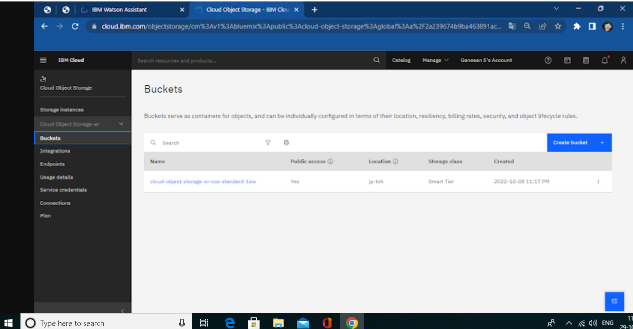

**Question-2:**

Upload an 5 images to ibm object storage and make it public. Write html code to displaying all the 5 images.

**Solution:**

Html code:

<!DOCTYPE html>

<html>

  <head>

    <title>

      cloud object images

    </title>

    <link rel="stylesheet" href="https://fast-nuces-data-11.s3.jp-tok.cloud-object-storage.appdomain.cloud/new.css">

  </head>

  <body>

    <b>These Images are for Inventory management system</b>

    <div class="wrapper">

      <div class="box"><img src="https://fast-nuces-data-11.s3.jp-tok.cloud-object-storage.appdomain.cloud/11.jpg"></div>

      <div class="box"><img src="https://fast-nuces-data-11.s3.jp-tok.cloud-object-storage.appdomain.cloud/13.jpg"></div>

      <div class="box"><img src="https://fast-nuces-data-11.s3.jp-tok.cloud-object-storage.appdomain.cloud/14.jpg"></div>

      <div class="box"><img src="https://fast-nuces-data-11.s3.jp-tok.cloud-object-storage.appdomain.cloud/15.jpg"></div>

      <div class="box"><img src="https://fast-nuces-data-11.s3.jp-tok.cloud-object-storage.appdomain.cloud/16.jpg"></div>

    </div>

  </body>

</html>

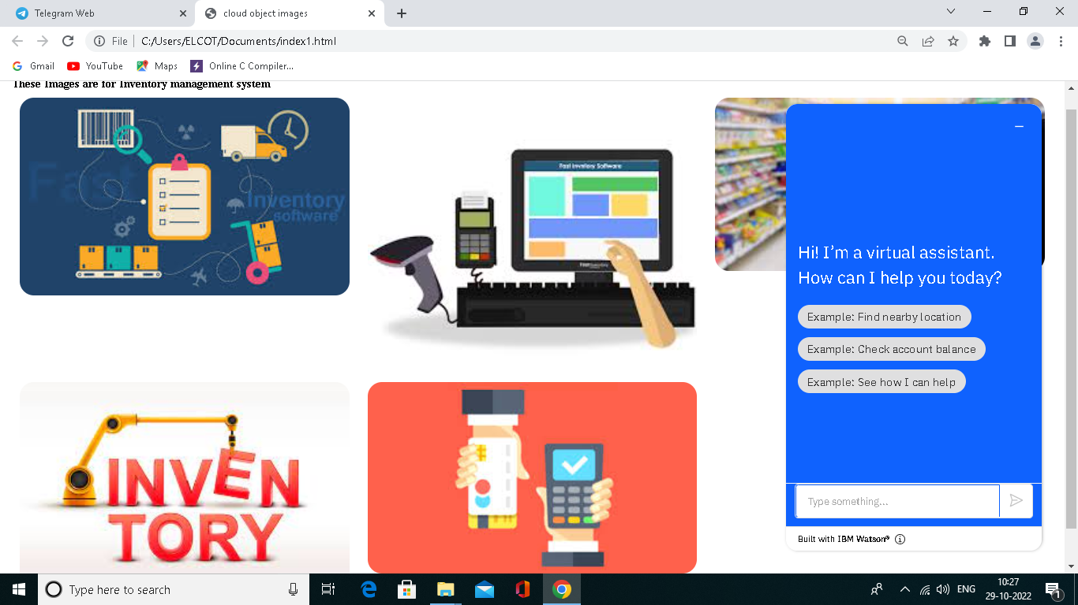

**Question-3:**

Upload a css page to the object storage and use the same page in your html code.

Solution:

New.css uploaded to the object storage and used the same page in html code

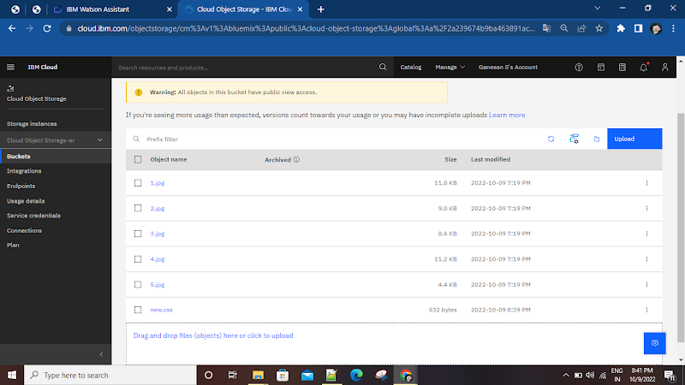

**Question-4:**

Design a Chabot using IBM Watson assistant for hospital. Ex: User come the query to know the braches for that hospital in your city. 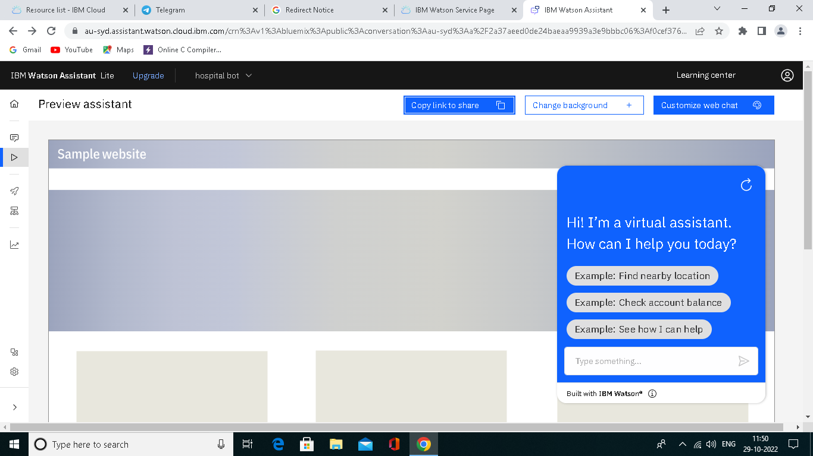

**Question-5:**

Create Watson assistant service with 10 steps and use 3 conditions in it. Load that script in html page

Solution:

<!DOCTYPE html>

<html>

<head>

<title>

cloud object images

</title>

<link rel="stylesheet" href="https://fast-nuces-data-11.s3.jp-tok.cloud-object-storage.appdomain.cloud/new.css">

</head>

<script>

window.watsonAssistantChatOptions = {

integrationID: "deea1e41-c618-4cbd-8a6d-60bda08ef5f9", // The ID of this integration.

region: "au-syd", // The region your integration is hosted in.

serviceInstanceID: "f0cef376-9d62-4898-afec-328436a2c38e", // The ID of your service instance.

onLoad: function(instance) { instance.render(); }

};

setTimeout(function(){

const t=document.createElement('script');

t.src="https://web-chat.global.assistant.watson.appdomain.cloud/versions/" + (window.watsonAssistantChatOptions.clientVersion || 'latest') + "/WatsonAssistantChatEntry.js";

document.head.appendChild(t);

});

</script>

<body>

<b>These Images are for Inventory management system</b>

<div class="wrapper">

<div class="box"><img src="https://fast-nuces-data-11.s3.jp-tok.cloud-object-storage.appdomain.cloud/11.jpg"></div>

<div class="box"><img src="https://fast-nuces-data-11.s3.jp-tok.cloud-object-storage.appdomain.cloud/13.jpg"></div>

<div class="box"><img src="https://fast-nuces-data-11.s3.jp-tok.cloud-object-storage.appdomain.cloud/14.jpg"></div>

<div class="box"><img src="https://fast-nuces-data-11.s3.jp-tok.cloud-object-storage.appdomain.cloud/15.jpg"></div>

<div class="box"><img src="https://fast-nuces-data-11.s3.jp-tok.cloud-object-storage.appdomain.cloud/16.jpg"></div>

</div>

</body</html>

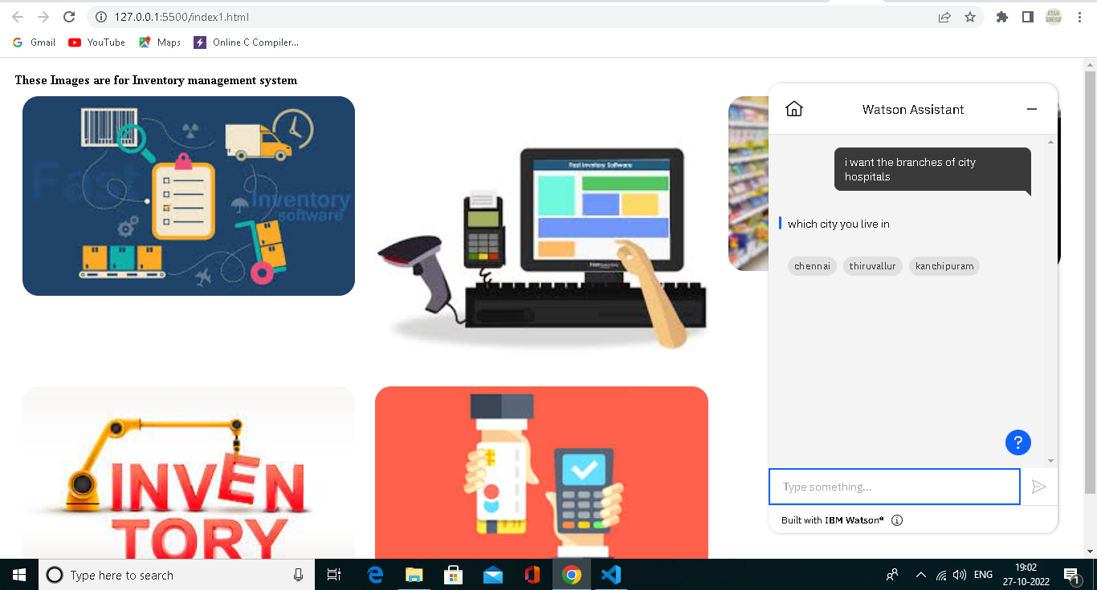

**URL for chatbot:**

https://web-chat.global.assistant.watson.appdomain.cloud/preview.html?backgroundImageURL=https%3A%2F%2Fau-syd.assistant.watson.cloud.ibm.com%2Fpublic%2Fimages%2Fupx-f0cef376-9d62-4898-afec-328436a2c38e%3A%3Aeddcecec-e6a9-450b-8274-9a08d249fee1&integrationID=0a7960eb-bfb9-4e97-b62b-45809447490b&region=au-syd&serviceInstanceID=f0cef376-9d62-4898-afec-328436a2c38e